Close Front Door Design

Server Overview
Current processing – When TPF is down CBOEdirect has to close or halt all of its options products and strategies.

New approach – When TPF is down all affected CBOEdirect products will be put into a (new) ‘suspended’ state. This will be a manual step, executed by Operations or Help Desk via the SAGUI. When suspended, all current quotes are cancelled and no new orders or quotes will be accepted. After TPF is restored, the products will be manually transitioned to pre-open, and then opening rotation.

New “Suspended” Product State
- We will be introducing a new state of “suspended” to represent a trading “halt” that will not be disseminated as such to OPRA. Valid state transitions relating to the suspended state are as follows: “(any state) → suspended”, “suspended → closed” “suspended → (pre-open, $no_session$, suspended)”.
- Note that all firms will be receiving a new enumerated type.

Manual State Transitions
- A product can only be transitioned from “suspended” to “pre-open” manually. Neither PDS data nor TSS timers will be honored, unless a new config param for TSS (“flagManualStateChanges”) is set to “true”, which will allow timers to override the suspended state.

Suspending Hybrid Products
- The PSS in a HyTS will accept the transition to “suspended”. All services currently looking for a product state of “closed” or “halted” will also process “suspended”. The suspended state change will not be propagated to TPF since the ‘Best Quote Service’ will ignore the unhandled state of “suspended”.

Suspending Non-Hybrid (RTH) Products
- The PDS adapter may be enabled, thereby providing current product state for RTH products. The PSS in the ExtTS currently maintains a state of “no session” or “closed”. The PSS will be enhanced to support state transitions to and from “suspended”.
- Issue: while suspended, we want to prevent the PDS adapter from publishing product state events. This will be accomplished by having the PDS adapter listen for product state events from all trade servers. If it receives a ‘suspended’ state, then the adapter will ignore all state events from PDS for that product/class, and only begin accepting them again after an “admin request” is executed by support personnel. After the request is executed, any pending state changes in PDS will be published.

Sequence Numbers & Product State Messages
- Since both PSS in ExtTS and PDS adapter will be publishing state events for the same products, we need to resolve conflicting sequence numbers. We will accomplish this by implementing a new sequence number strategy based on the current second rather than the initialization time.
- There is still a possibility that messages send by both originators in the same second will be out of sync, however sub-second differences in origination time between DN clouds are relatively benign; it would be meaningless to prove that the ‘suspended’ event from PSS came before or after the ‘open’ event from PDS in the same second.
- This strategy will only be effective if all machine clocks on all BC’s & GC’s are reasonably in-sync.
- There is still a risk that CAS could miss the “suspended” event if it is published in the same second as a PDS-originated state change. Both server and client teams consider this an unlikely and acceptable risk.

Item needs to be changed:-

- Scripts
- setAllProductStates
- setAllProductStatesForSession
- setProductStateForTradeServer
- showProductStatesBySession

- Database
- None

- setContext
- None

- XML/DTD
- TradingSessionService: param & admin request to (dis)allow automatic transition from “suspended”. Default is false.

- Homes/Services (5)
- ProductStateService
- TradingSessionService
- BrokerService (strategy factory)
- TPFBestQuoteService
- PDSMarketDataUpdate

- IDL
- cmiConstants.idl

- Implementation Plan
- GC first, then BC’s.

- TestingProcedure(1)
- Include tests for new valid state transitions in hybrid & non-hybrid.

- OperatorProcedure(.5)
- Describe ar command to set the state transition flag. Describe the unified CD/TPF failover procedure. *Note: the unified procedure will be completed in a different feature task.

- Fallback/Failover
- Regular fallback procedures apply.

GUI Overview
This will require the GUI to be able to set and handle a new state of SUSPENDED. Both the Product State Maintenance screen and the Product Control tab of the Trading Session Management screen will need changed.

Product State Maintenance
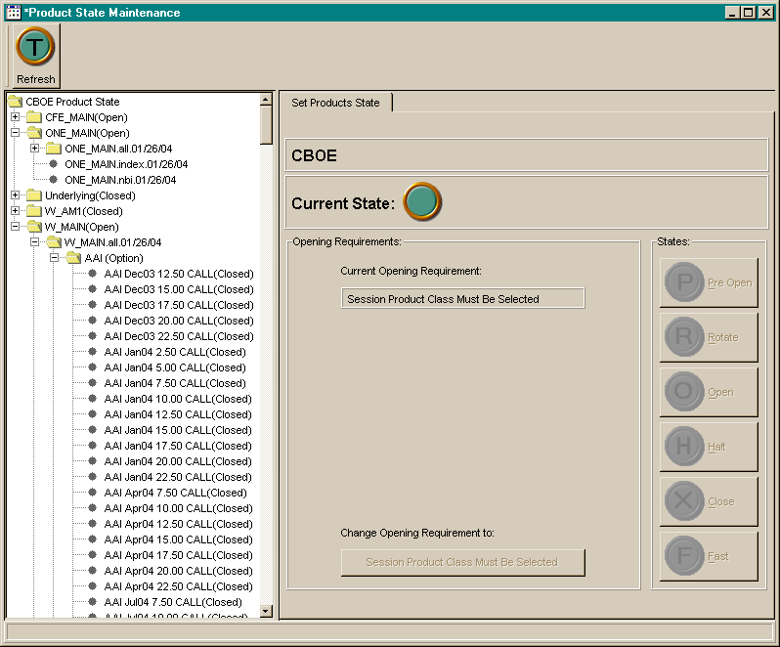

Menu Navigation and Toolbar
The new menu bar that was added as part of the Product State by Trade Server will need to be modified to reflect the new state that can be set.

Products
Change State
Pre-Open
Rotate
Open
Halt
Close
Fast
Suspended
Change Opening Req.
(text will vary, based on selection)
<separator>
Refresh
<separator>
Close
Edit
Mode
Enable Support Mode

This new menu item should be a reusable action object so that we can represent it as other GUI components as well.

State Change Button Panel
The existing state change button panel will need a new button and graphic to represent the state.

Current State Panel
We need to make sure this panel can reflect this new state. Including a new graphic.

Formatters
The class ProductStates in the formatter package needs modified to accept and format the new state.

Activity Reasons
The class for formatting ActivityReasons will need to change to reflect the new state.

Check other uses of cmi ProductStates constants usage.

Release Issue
In the initial version the button and menu item to change the state to Suspended will be permanently disabled, without anyway to enable it. This is required because the server rollout cannot handle us setting this state until the rollout is complete. We will do all coding for this, but add code to ensure that the action stays disabled. After the complete rollout is complete, we will release a bug fix that will allow this action to be enabled in the same fashion as the rest of the actions. This later bug fix should require as minimal of a change as possible.

Trading Session Management
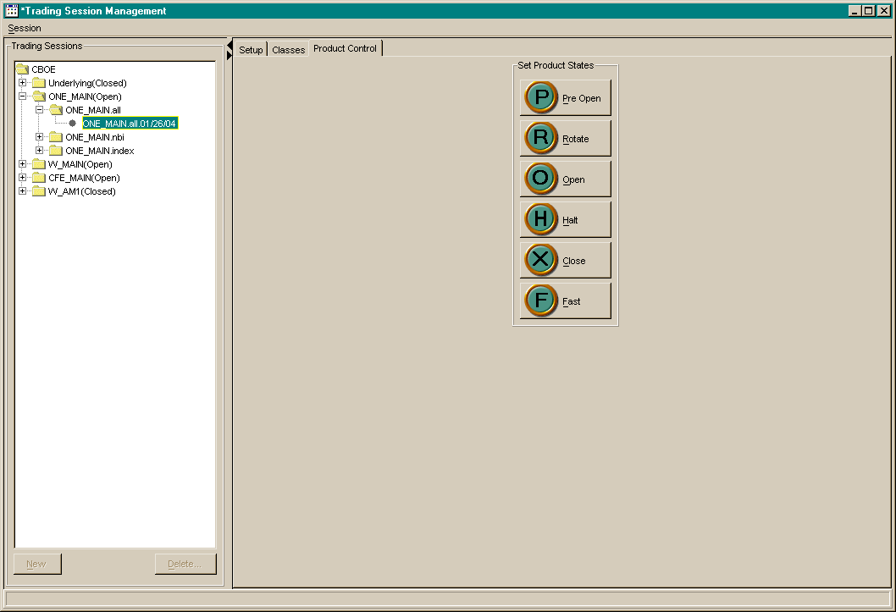

State Change Button Panel
The existing state change button panel will need a new button and graphic to represent the state.

Release Issue
In the initial version the button and menu item to change the state to Suspended will be permanently disabled, without anyway to enable it. This is required because the server rollout cannot handle us setting this state until the rollout is complete. We will do all coding for this, but add code to ensure that the action stays disabled. After the complete rollout is complete, we will release a bug fix that will allow this action to be enabled in the same fashion as the rest of the actions. This later bug fix should require as minimal of a change as possible.

